Canine Chronicles: A Lifespan Odyssey

Export of <https://partyrock.aws/u/Priti-r123/t4QRhJ5f0/Canine-Chronicles%3A-A-Lifespan-Odyssey>

# Instructions

This app will generate three high-resolution images of dogs, each representing a different age stage: puppy (3 months old), adult (3 years old), and senior (10 years old). Each image should vividly capture the distinct characteristics associated with that life stage.

# Puppy Image



# Adult Dog Image

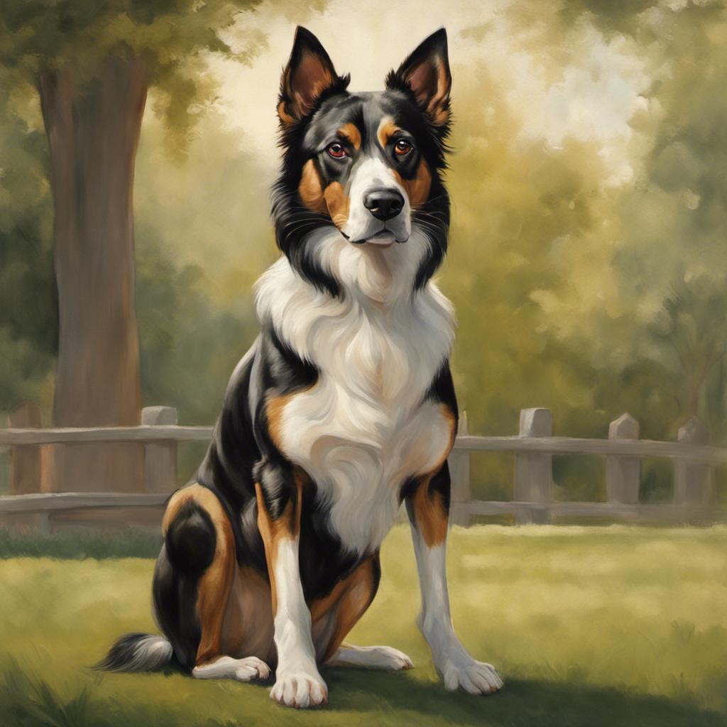

# Senior Dog Image

